# Topology

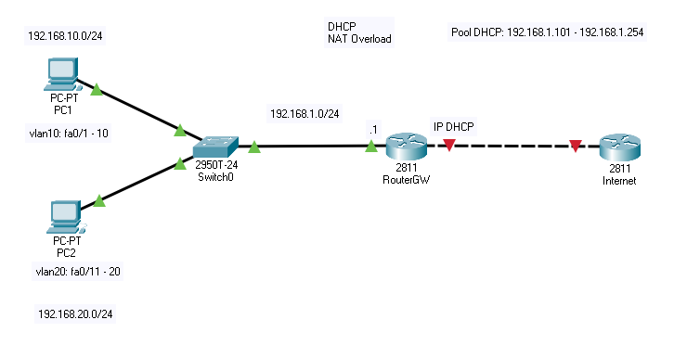

## Switch Switch0

Switch(config)#vlan 10

Switch(config-vlan)#name vlan10

Switch(config-vlan)#ex

Switch(config)#vlan 20

Switch(config-vlan)#name vlan20

Switch(config-vlan)#ex

Switch(config)#int range fa0/1 - 10

Switch(config-if-range)#switchport mode access

Switch(config-if-range)#switchport access vlan 10

Switch(config)#int range fa0/11 - 20

Switch(config-if-range)#switchport mode access

Switch(config-if-range)#switchport access vlan 20

# Router RouterGW

## Interface config

Router(config)#hostname RouterGW

RouterGW(config)#int fa0/1

RouterGW(config-if)#ip address 192.168.1.1 255.255.255.0

RouterGW(config-if)#no shut

RouterGW(config-if)#ip nat inside

RouterGW(config-if)#ex

RouterGW(config)#int fa0/0

RouterGW(config-if)#ip address dhcp

RouterGW(config-if)#ip nat outside

RouterGW(config-if)#ex

## Sub-Interface config

Router(config)# int f0/1.10

RouterGW(config-subif)#encapsulation dot1Q 10

RouterGW(config-subif)#ip add 192.168.10.1 255.255.255.0

RouterGW(config-subif)#no shutdown

Router(config)# int f0/1.20

RouterGW(config-subif)#encapsulation dot1Q 20

RouterGW(config-subif)#ip add 192.168.20.1 255.255.255.0

RouterGW(config-subif)#no shutdown

## DHCP Pool

RouterGW(config)#ip dhcp pool vlan10

RouterGW(dhcp-config)#network 192.168.10.0 255.255.255.0

RouterGW(dhcp-config)#default-router 192.168.10.1

RouterGW(dhcp-config)#ex

RouterGW(config)#ip dhcp pool vlan20

RouterGW(dhcp-config)#network 192.168.20.0 255.255.255.0

RouterGW(dhcp-config)#default-router 192.168.20.1

RouterGW(dhcp-config)#ex

Router(config)#ip dhcp excluded-address 192.168.10.1 192.168.10.100

Router(config)#ip dhcp excluded-address 192.168.20.1 192.168.20.100

## Access list config

RouterGW(config)#access-list 1 permit 192.168.1.0 0.0.0.255

RouterGW(config)#access-list 1 permit 192.168.10.0 0.0.0.255

RouterGW(config)#access-list 1 permit 192.168.20.0 0.0.0.255

RouterGW(config)#ip nat inside source list 1 int f0/0 overload